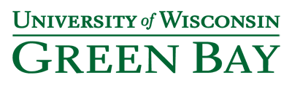
Nursing and Health Studies

Welcome to the annual edition of our Alumni Newsletter. We want you to stay connected and informed about alumni, recent graduates, faculty and staff as well as news about your alma mater. Send us updates with your good news! Also, refer any RN’s who may be interested in our BSN or MSN programs.

Published January 2018

Department Name Change: We have changed our department name from the “Professional Program in Nursing” to “Nursing and Health Studies”. The new name more accurately characterizes all of our programs as we have added non-nursing degrees in Health Information Management & Technology as well as the Master of Science in Health & Wellness Management.

MSN Fall 2018 Applications: Applications are being accepted for the Fall 2018 cohort of the MSN Leadership & Management in Health Systems. The Priority Deadline is March 1 and the final deadline is July 1. If you have been considering returning for an MSN, now is a great time to apply! See the MSN Application Checklist.
Distinguished Alumni Award – Nominations Sought: We are seeking nominations for the Nursing Distinguished Alumni Award. The award is given annually to a UW-Green Bay nursing graduate (BSN or MSN). Criteria upon which nominees are evaluated include:

- Service or leadership enhancing the profession of nursing and/or community

- Achievements demonstrating a high level of professionalism and modeling values of the nursing profession (e.g. caring, altruism, social justice)

- Distinguished scholarly achievement (e.g., presentations, articles, etc.) and/or serving as a mentor/trainer in the field of nursing

Letters of nomination (including self-nomination) should not exceed two pages and be submitted in digital format to malchowj@uwgb.edu by recently extended deadline of April 1, 2018. Nominations are reviewed by a selection committee. The award recipient will be notified by May 15, 2018.

The following nominee information must be included: First and Last Name; Last Name at Graduation; Year of Graduation; Current email address; Mailing Address (Street, City, State, Zip); Phone; Current Employer and Position Title.
Please include the name and email address of the person submitting the nomination and a current photo of the nominee.

Alumni Award recipients will receive official recognition on the UW-Green Bay nursing website and in the Alumni Newsletter, an award certificate and engraved pen.

For more information, contact Mr. Jan Malchow, Manager of Student Outreach at 920-465-2722 or malchowj@uwgb.edu .

Kubsch Scholarship To Make First Award: The Mimi and Ken Kubsch Endowed Scholarship was established to recognize Dr. Mimi Kubsch and her late husband Dr. Ken Kubsch, a well known physician in the Green Bay area. Donations as of December 2017 reached $15,784 in the Endowed Fund which will result in an annual $500 scholarship award! The scholarship will be awarded to an enrolled nursing student (BSN or MSN) preferably who demonstrates proficiency in Holistic Nursing.

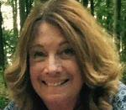
Dr. Mimi Kubsch, recipient of 2014 UW-Green Bay Founders Award for Excellence in Teaching, is honored with Kubsch Endowed Scholarship.
Our goal is to reach $25,000 invested in the Scholarship Endowment in order to award 2- $500 scholarships each year. If you haven’t already given, please consider doing so soon. Click here to make your gift.

Alumni Updates: Irene Kelly (2014)
Irene (Rena) Kelly has been busy pursuing her MSN with an emphasis in Education from Grand Canyon University. She has been instructing a Pathophysiology course as her practicum. She plans to graduate in April.

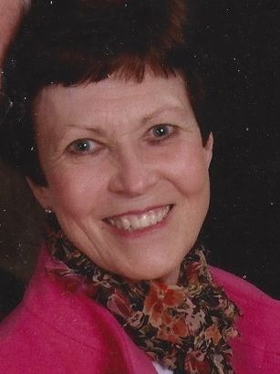Rena Kelly – 2014 gives back to her alma mater!

Rena attributes much of her success to our UWGB BSN program. In particular, she shared that Dr. Mimi Kubsch “is a special person, wonderful mentor and caring instructor who challenges and encourages her students.” Rena recently contributed a second lead gift of $1000 to the Kubsch Scholarship. She hopes other nurses “would honor their education and remember nurses who were important in their lives – whether “healing” or teaching.”

Global connections: Master of Nursing (MSN-online) student Renee Payne takes her first steps on campus
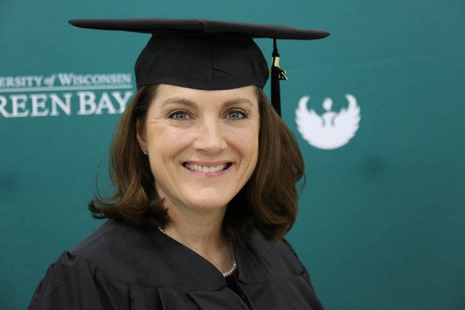
Renee Payne (BSN 2011; MSN 2017) stepped foot on campus for the first time during the Spring/Summer 2017 commencement ceremony (May 13, 2017), despite graduating with a Master’s of Science in Nursing (MSN-LINC) in Leadership and Management in Health Systems degree. In fact, she worked toward her degree from across the United States and around the globe.
The Florida native knew she wanted to become a nurse at 14 when she volunteered at a local hospital. After receiving her degree as a registered nurse (RN), she met her husband, a U.S. Air Force officer. Following his career, they moved on average every 1 to 2 years from Germany to South Korea and throughout the United States.
Renee wanted to earn her Bachelor of Science in Nursing (BSN), but she didn’t know how with the frequent moving and young children at home. After hearing about UW-Green Bay’s online BSN program from another Air Force spouse, she applied. After completing her BSN, she continued her education in UW-Green Bay’s MSN program.
Renee’s career goals include becoming a nurse leader and educator. She would like to highlight the importance of safe staffing levels in patient outcomes and be a voice for nursing and patients via political activism.
“I feel as if it is my responsibility to speak up and fight for my patients and my nurse colleagues,” said Payne. “That’s the reason I went back to school to obtain my MSN. I want to be part of a solution to improve patient outcomes in the U.S. as well as prepare the generation of nurses after me to continue to make improvements.”
She is now living in Dayton, Ohio with her family.
Jennifer McKown (MSN 2017) completed an internship at the National Council of State Boards of Nursing Regulatory Scholar Graduate Experience Program in Chicago this past summer. This prestigious internship offered students like Jennifer practical experience in nursing regulatory/ policy.

Jennifer is employed as the Assistant Director of Healthcare Services at the Lutheran Home, a 480 bed full continuum nursing home in Arlington Heights, Illinois. She oversees a post-acute skilled nursing rehabilitation unit; serves as the Clinical Education Coordinator; and is the designated Infection Preventionist.

Roxanne Tienor (MSN 2015) and Allison Reitzner (MSN 2015) both moved into nursing management positions since graduation at Humana Insurance and NEW Mental Health Facility, respectively.

HIMT Grad Boosts Career: As a healthcare business analyst for Marshfield Clinic Information Systems (MCIS), Melissa Metz (HIMT 2017) uses her health information management (HIM) and health IT experience and knowledge every day.

“I expected to be working with numbers every day, but there’s so much more to my job,” Melissa says. MCIS provides electronic health record (EHR) products and services to all types of healthcare organizations, including Marshfield Clinic Health Systems, a leading provider of healthcare services. In her position, Melissa works with clients and MCIS’s development team to get new EHR systems up and running.
“MCIS is the only healthcare software organization in my area, so health IT jobs are competitive. I think it was my thorough understanding of HIM and health IT that got me the healthcare business analyst job over many other applicants.”
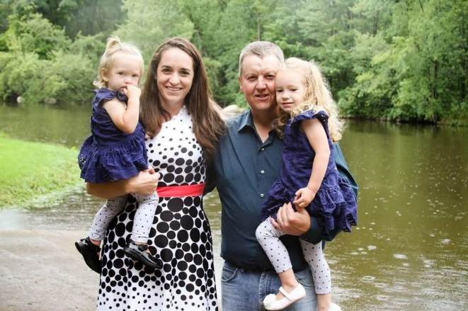
HIMT Graduate, Melissa Metz and her family.
NURSE 1-2-1 Launches: We are in the second year of this new BSN program. The program is a collaboration with Northeast Wisconsin Technical College and is geared towards students with less than 15 college credits looking for a campus experience and wishing to complete the BSN in four years. For more information, consult the website.

New MS in Health & Wellness Management: Also in its second year, this new online Masters of Science program is designed for working adults with real life experience wishing to strengthen their knowledge of corporate wellness and health promotion. The curriculum will prepare students for high level leadership positions. It is a collaboration offered by UW-Extension and five UW campuses (Green Bay, Parkside, River Falls, Stevens Point and Superior). Consult our website for more information.

Congratulations to all of our graduates!
Fall 2016: We celebrated with 50 BSN and 5 HIMT graduates.
Spring & Summer 2017: We celebrated with 62 BSN, 16 HIMT and 13 MSN graduates.
Fall 2017: We celebrated with 43 BSN, 13 HIMT and 3 MSN graduates. For a list of all graduates, please see our web site news blog.
Travel Course: Drs. Janet Reilly and Rebecca Hovarter are planning a trip to Slovakia practicing community-based nursing interventions with the vulnerable Roma population from June 8-18 of 2018. Alumni are invited to participate in the trip which will include visits to the beautiful cities of Vienna, Austria; Krakow, Poland; the Danube River, High Tatras Mountains; and historic castles. The course will also offer BSN students the opportunity to complete the Community Health Practicum course (N455). (The online portion of the N455 course runs from May 21 to June 30.) Registration deadline for the course (including the trip) is March 1. To register, see the Office of International Education web site. Contact Dr. Reilly or Dr. Hovarter for more details.

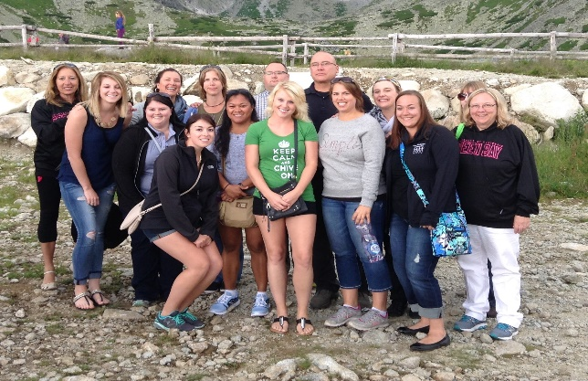
Photo from Slovakia Trip 2016
Sigma International Honor Society of Nursing, Kappa Pi Chapter –Join Today! The mission of Sigma International Honor Society of Nursing is to support the learning, knowledge, and professional development of nurses committed to making a difference in health worldwide. As a chapter in this prestigious nursing honor society, Kappa Pi works to advance this mission through our activities. Renew your membership or join as a nurse leader today. Click on the "Membership" tab on the Sigma website http://www.sigmanursing.org/ for more information.
If you are a practicing nurse, you are eligible to join if you are legally recognized to practice, have a minimum of a baccalaureate degree in any field, and have demonstrated achievement in nursing. Additional information and application guidelines are available under the "Membership" tab on the Sigma website.To learn more about our Chapter, Kappa Pi Visit the chapter website, http://kappapi.nursingsociety.org/home.
“Sigma is designed to meet your specific needs at every stage of your career.” As fellow alumnus of UWGB and an active member of Kappa Pi, I encourage you to join!
Sharon Gajeski UWGB BSN class of 1985
BSN@HOME Program Earns National Award: The University Professional and Continuing Education Association (UPCEA) recognized the BSN@HOME program with the 2016 Celebration of Excellence Award for Mature Program. UPCEA is the leading association for professional, continuing and online education and serves more than 400 institutions, including most of the leading public and private colleges and universities in North America. The Mature Program Award recognizes established credit or noncredit programs that have demonstrated sustained innovation.
Faculty News:
Dr. Susan Gallagher-Lepak was named the first Dean of the new College of Health, Education and Social Welfare in 2016. Nursing and Health Studies is one department in the new college. Congratulations and best wishes!

Dr. Christine Vandenhouten was named the Chair of Nursing and Health Studies in addition to being the Program Director of the RN to BSN programs in 2016. She also serves as the Academic Director of the MS in Health and Wellness Management program. Congratulations!

Dr. Myunghee Yun joined the Nursing and Health Studies faculty in 2017. Most recently, Dr. Jun was a visiting professor at UW-Milwaukee and Senior Researcher with CHUN-ANG University in South Korea. From 1995 to 2013, she was a Nursing Professor at DAEJEON University in South Korea. Welcome Dr. Yun!

Dr. Brenda Tyczkowski was the lead author of a chapter of a text book which has been awarded First Place in the gerontological nursing category of the American Journal of Nursing Book of the Year Awards for 2017. Dr. Tyczkowski was the lead author for Chapter 19: The Gerontological Nurse as Manager and Leader within the Interprofessional Team. The book is Gerontological Nursing Competencies for Care (2018) (Ed. Mauk, K.) Jones and Bartlett. Congratulations!

New ADN Program Partners: We are pleased to announce that Bay College (Escanaba, MI) and Lake Michigan College (Benton Harbor, MI) have agreed to be new partners with our RN to BSN program. Under the partnerships, a minimum of 60 credits transfer for holding the associate degree and an active RN license. Additional courses which transfer to meet BSN degree general education and nursing major support requirements from the partner schools are identified on a credit transfer table.

Partner campuses host UW-Green Bay staff at continuing education fairs and promote our program for completion of the BSN. A similar partnership arrangement is being developed with health care systems and other employers of nurses. If your employer would be interested in offering our program materials to employees; hosting our staff for continuing education opportunities; or having position openings featured in our social media postings to recruit staff, please contact Jan Malchow our Manager of Student Outreach to learn more.

New Job Posting Service added to Website: LiquidCompass, a job search resource, has been added to our nursing and healthcare website. LiquidCompass tracks the hiring activity of all major employers across the United States and updates Hiring Sheets daily. Check out the website for more information.

We want to hear from you:
Can we help you with a:
- Graduate school reference?
- Transcript?
- Question about MSN-LINC?

Please tell us of your professional accomplishments including:
- New jobs
- Publications
- Successes at work
- Education after graduation
- Awards or recognition
- Family updates

Please send information requests or updates to: Mr. Jan Malchow, Manager of Student Outreach & Alumni Relations at malchowj@uwgb.edu or by calling (920) 465-2722 or toll free at 888-674-8942.

“Like” us on Facebook and receive quick updates about our Nursing Program. It’s your opportunity to stay connected.

The UW-Green Bay Nursing & Health Studies Alumni Newsletter is an annual publication. For additional news and information about our programs, visit the program website at www.uwgb.edu/nursing. Individual comments, alumni updates or questions about making a donation or scholarship gift to the program and your alma mater can be directed to Mr. Jan Malchow, Manager of Student Outreach and editor of the Alumni Newsletter at malchowj@uwgb.edu.

