University Planning and Innovation Design

University of Wisconsin – Green Bay

September 22, 2014

A new process for long range strategic planning and innovation is described. The process provides for a two-year pre-biennium planning schedule, a mechanism to anticipate important forces in the environment and future needs for incorporation into university planning and a platform for the careful but timely consideration of innovations. The process provides the university with a mechanism to analyze and respond quickly to important challenges and opportunities. The new design incorporates more transparency into the strategic planning activities of the university.

The centerpiece of the process is the University Planning and Innovation Council (UPIC), a high level strategic planning body appointed by the Chancellor upon the recommendations of University governance bodies. The UPIC will be established immediately and participate in planning for both the 2015-17 and 2017-19 biennia.

Planning Environment

The State of Wisconsin operates on a biennium budget with each new biennium beginning in the odd numbered year (Figure 1). Typically, university planning for the next biennium begins in the fall prior to the beginning of the approaching biennium. For example, the university will soon begin planning for the 2015-17 biennium (which begins in July of 2015; see Figure 1). Annual adjustments in the university budget are made as needed during the biennium (not shown in Figure 1). This planning cycle places the university in a reactive mode and affords little time and no campus-wide process for consideration of important strategic initiatives.

Currently, pre-biennium planning is confined to the development of budgets. The process does not include university-level discussions of mid to long-term strategic priorities and innovations. Nor does the current process explicitly link to the university strategic plan. Budget requests are developed from the units up and coalesced into a budget request based primarily on proximate factors (e.g., current allowable tuition increase, state budget situation, etc.) not on consideration of broader university goals.

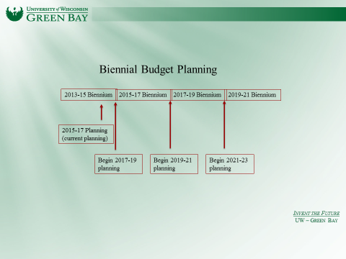
Figure 1. Biennial budget planning cycle.

The new plan will lengthen the strategic planning horizon to two years giving the university time for careful reflection about which parts of its strategic plan to emphasize in the coming years.

Innovation Environment

Despite the extremely innovative history of the University of Wisconsin Green Bay, the university currently has no formal process for generating and considering game-changing ideas about its operations and programs. Given the state budget climate, large demographic shifts and the highly dynamic nature of contemporary higher education, the opportunity to leverage the innovation heritage of UWGB to develop ground breaking models of higher education and university-community partnerships is vast. The new planning process is designed to provide a focal point for institutional innovation in these changing times.

Strategic Environment

The University Strategic Plan is built around seven broad themes: (1) Academic Programs and Enrollment, (2) Commitment to Community, (3) Diversity and Institutional Environment, (4) Finance, Budget, Resources, (5) Identity, Image, Marketing, (6) Meeting the needs of students and (7) Sustainability. Goals and objectives were developed for each strategic theme (e.g., In Academic Affairs there are eight goals and a total of 33 objectives embedded within those eight goals). Progress on each goal is tracked using a balanced scorecard approach.

In addition to the institutional strategy, the UW system applies goals which in recent years have been related to the UW System Growth Agenda. The system strategic agenda is changing under the direction of a new President and will be oriented more toward economic development and talent creation. Currently, funding does not depend directly on institutional performance on system goals.

The biennial funding allocation for Wisconsin public universities is a base plus/minus model whereby, the university’s current base budget is adjusted up or down through a series of system-level decisions regarding: Utilities, debt service (campus budgets simply hold state allocations for debt service), fringe benefits, new initiatives, compensation (compensation plans are funded both from state allocations and tuition), recruitment and retention, other (e.g., student technology fees, approved fee increases, etc). An overarching assumption – which has not been followed in recent years – is that the cost of new initiatives and compensation programs approved at the state level will be shared by state appropriation and appropriate increases in tuition. So, increases in the base are generally accomplished by additional tuition rather than an increase in GPR.

Despite the centralized allocation approach – typical of most state higher education systems—because the university receives more support from tuition and other resources than from the state appropriation (GPR) and because the university keeps all net new tuition, there is room for institutional growth in an environment with growing enrollments. Such tuition-driven growth must be carefully constructed in order to weather times of enrollment increases.

In addition to the system and institutional strategic framework, the ability of the university to move forward with specific strategic goals also depends on its success in philanthropy and, more and more, its ability to create and sustain partnerships with business and NGOs that add value to both partners (in terms of the university, “value” means opportunities for students and faculty, direct revenue or opportunities for additional partnerships).

Strategic success also depends on the ability of the university to organize itself for innovation and growth, offer a clear and compelling academic program and profess a narrative about itself that captures the imagination of potential students, generates passion and energy for partnerships in the community and serves as the chief intellectual leader for major regional efforts to sustain the economy and improve the human condition.

The strategic landscape, then, includes all of the factors of budget, regulation, internal organization, academic program portfolio, and partnership philosophy of the university.

The New Planning Design

The important feature of the new planning design is the University Planning and Innovation Council (UPIC). The UPIC will be co-Chaired by the Provost and the Vice Chancellor for Business and Finance (VCBF). Members will be appointed by the Chancellor upon the recommendation of the four governance groups. Members will be appointed for staggered multi-year terms in order to leverage experience and accommodate new ideas. The UPIC will be staffed by the offices of the Provost and the Vice Chancellor for Budget and Finance and will meet on a regular schedule.

The relationship of the UPIC to the university governance structure, to the Chancellor and the Cabinet is depicted in Figure 2.

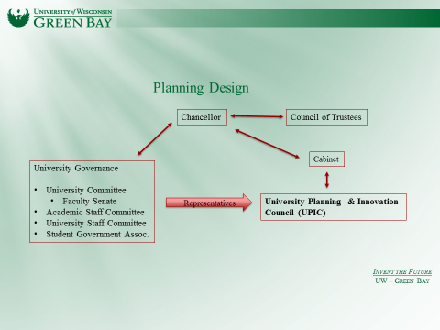
Figure 2. Relationship of UPIC to university
Governance structure.

The UPIC works in collaboration with the Cabinet. Recommendations of the UPIC are evidence-based and are developed through analysis, study and consultation. Recommendations are approved by the Chancellor.

Membership of the University Planning and Innovation Council

In order to succeed, UPIC members must be committed to the commonwealth mission of the university and to a sustained (up to four year terms; see below) period of intensive learning, consultation and strategic thinking and planning. The UPIC is not intended to be a representative body. Rather, it is expected to operate with the same level of collective institutional view of the Chancellor and the Cabinet. Members of the UPIC will be expected to put aside favored agendas in order to consider the university as a whole. The suggested membership of the committee is shown in Table 1.

Table 1. University Planning and Innovation Council Membership.
Membership Group | Initial Appointment | Term (yrs.) | Recommended By
Provost | Fall 2014 | Permanent | NA
VC Business & Finance | Fall 2014 | Permanent | NA
Dean | Fall 2014 | 1 (rotating with other dean) | Deans
Faculty member | Fall 2014 | 2 | University Committee
Faculty member | Fall 2014 | 2 | University Committee
Faculty member | Fall 2014 | 4 | University Committee
Faculty member | Fall 2014 | 4 | University Committee
Academic staff | Fall 2014 | 2 | Academic Staff Com.
Academic staff | Fall 2014 | 4 | Academic Staff Com.
University staff | Fall 2014 | 2 | University Staff Com.
University staff | Fall 2014 | 4 | University Staff Com.
Athletic Director | Fall 2014 | Permanent | NA
Student | Fall 2014 | 1 | Provost

Charge of the University Planning and Innovation Council

The UPIC is a group of uncommonly committed innovators willing to collaborate closely with university governance, the Chancellor and senior leadership to envision and invent the future of UWGB. The work of the UPIC involves both detailed analysis and planning as well as creativity about new programs and approaches. With regard to the former, the UPIC is campus group responsible for choosing among the vast number of possible strategic goals for the coming biennium. With regard to the latter, the UPIC will serve as the University Innovation Council. In that role, the group will vet large, institution-wide ideas for change and prepare recommendations regarding the risk and reward of undertaking such change. Among the most important activities of the UPIC are:

- Develop and recommend planning goals for the coming biennium.
- Develop and recommend limited number institution-wide strategic goals for the coming biennium and, in some cases, beyond.
- Analyze and develop recommendations regarding special opportunities or important challenges for the university.
- Seek, accept, analyze and make recommendations regarding innovative ideas for change (University Innovation Council function).
- Other activities assigned by the Chancellor.

The typical budget planning cycle for the UPIC is provided in Figure 4.

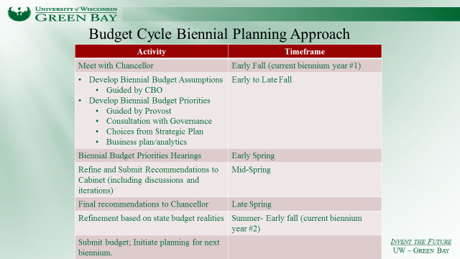

Figure 4. UPIC planning schedule.

Implementation Schedule and Considerations of UPIC Member Workload.
The UPIC will be established in the fall of 2014. Simultaneously, the University Budget Council will be discontinued, their work to be assumed by the UPIC. During the first year of operation, the UPIC will be involved in planning for both the 2015-17 and the 2017-19 biennia. The group will also assist the Chancellor in evaluating a number of current opportunities and in reviewing critical operational areas.
The UPIC is unlike any other committee or working group on campus. In order to be successful, the group must educate itself deeply about university operations and the external environment. The group must think broadly and strategically. It must be committed to evidence-based action and willing to accommodate the discomfort of making choices and accommodating change. The members of this group will be required to work at an extremely high energy level and commit considerable amounts of time. There will be no additional compensation for the work. Given this, it is important for the university reward structure to acknowledge and accommodate the activities of these individuals. Governance bodies should consider that the activities of UPIC members have a higher service value than typical committee work. Staff supervisors will be expected to accommodate the important work of the staff employees on the UPIC. The reward is to be involved at the very highest level in Inventing the Future of UWGB.
Relationship of UPIC to University Governance
The UPIC has no formal governance authority. It is an advisory body to the Chancellor and the senior leadership team. While the UPIC may consider issues historically within the purview of university governance, its conclusions regarding any such established prerogative of governance is advisory. The UPIC will enhance the participation of governance by routinely reporting to the various governing bodies and consulting them in the planning and innovation process.

